Introduction:
Text chunking is a fundamental process in Natural Language Processing (NLP) that involves breaking down large bodies of text into smaller, more manageable units called "chunks." This technique is crucial for various NLP applications, such as text summarization, sentiment analysis, information extraction, and machine translation. This article provides a detailed comparative analysis of different text chunking methods, exploring their strengths, weaknesses, and use cases.

Understanding Text Chunking
Text chunking, also known as text segmentation, involves dividing text into smaller units that can be processed more efficiently. These units can be sentences, paragraphs, or even phrases, depending on the application. The primary goal is to enhance the performance of NLP models by providing them with more contextually relevant pieces of text.

Why Chunk Text Data?
- Improved Processing Efficiency: Smaller chunks are easier to process and analyze.
- Enhanced Accuracy: Analyzing smaller, coherent chunks can yield more precise results.
- Better Context Management: Helps in maintaining the context of the text, which is crucial for tasks like machine translation and information retrieval.

Common Text Chunking Techniques
Several methods can be employed to chunk text data, each with its own set of advantages and limitations. Here, we compare some of the most popular techniques:

1. Fixed-Size Chunking
Fixed-size chunking involves dividing the text into chunks of a predefined size, typically based on the number of characters or tokens.
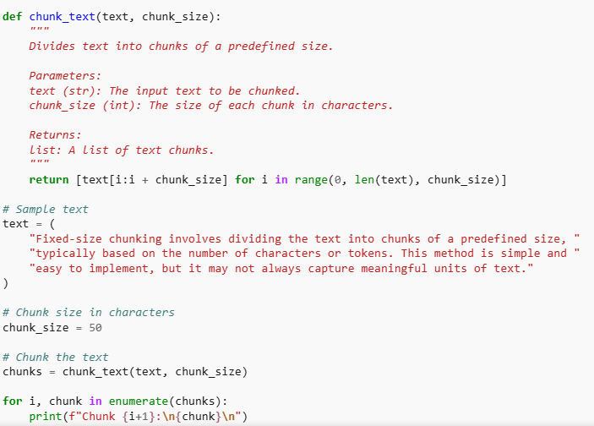
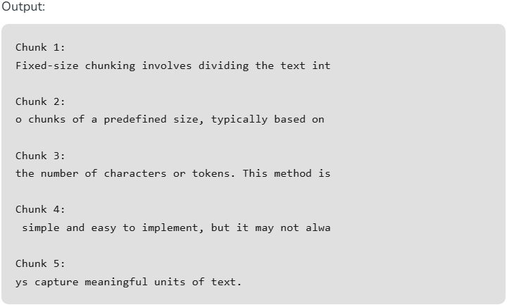

2. Sentence Splitting
Sentence splitting involves dividing the text into individual sentences using punctuation marks or NLP libraries.
Example 1: Sentence Splitting Using Punctuation Marks
This method involves splitting the text based on punctuation marks such as periods, exclamation marks, and question marks.
Punctuation-Based Splitting:
- The split_sentences_punctuation function uses a regular expression to split the text based on punctuation marks followed by a space.
- The regular expression r'(?<=[.!?]) +' matches periods, exclamation marks, or question marks followed by one or more spaces.
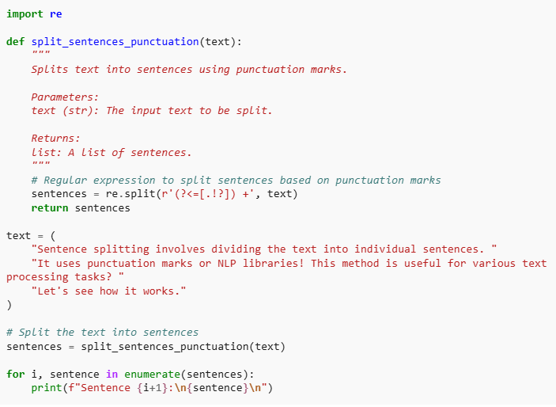
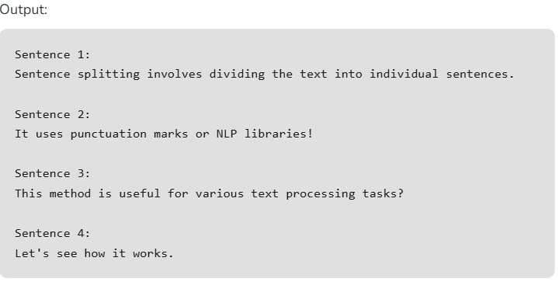
Example 2: Sentence Splitting Using an NLP Library (SpaCy)
Using an NLP library like SpaCy can provide more accurate sentence splitting by leveraging pre-trained models to understand the context.
NLP Library-Based Splitting:
- The split_sentences_spacy function uses SpaCy, a popular NLP library.
- It loads the English model (en_core_web_sm) and processes the text to extract sentences.
- SpaCy's sentence boundary detection considers linguistic rules and context, providing more accurate sentence splitting.
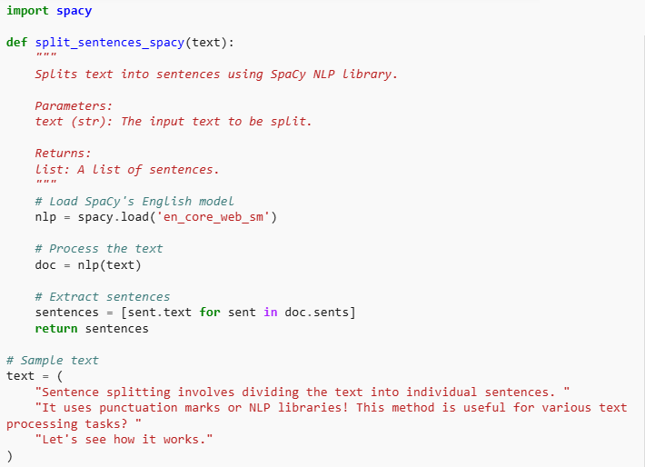
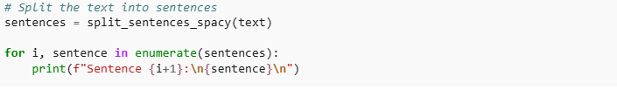
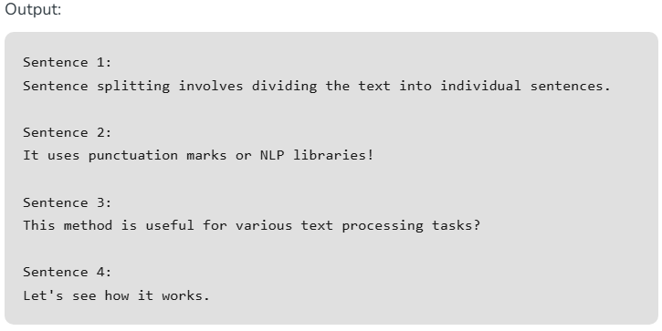

3. Recursive Chunking
Recursive chunking divides the text hierarchically using a set of separators. If the initial chunks are too large, the method recursively splits them until the desired size is achieved.
- recursive_chunk takes the input text, the maximum desired chunk size, and the current recursion level as parameters.
- It uses a list of separators (separators) to split the text at different levels: sentences and words.
- The sample text is recursively divided into chunks no larger than the specified maximum size (50 characters in this case).
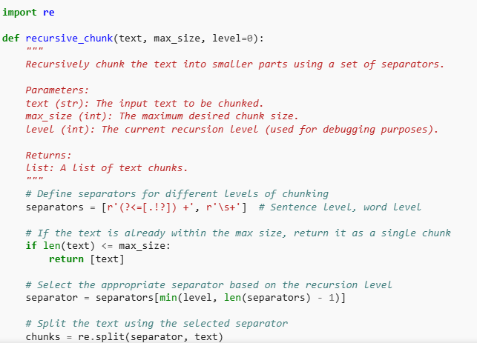
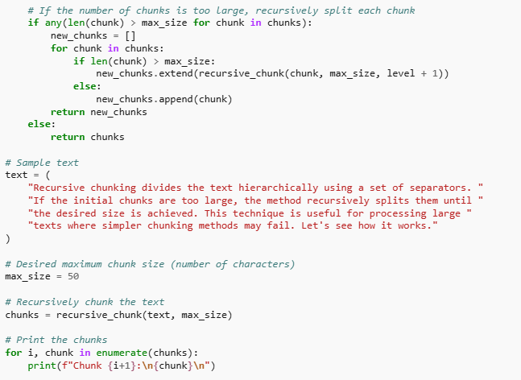
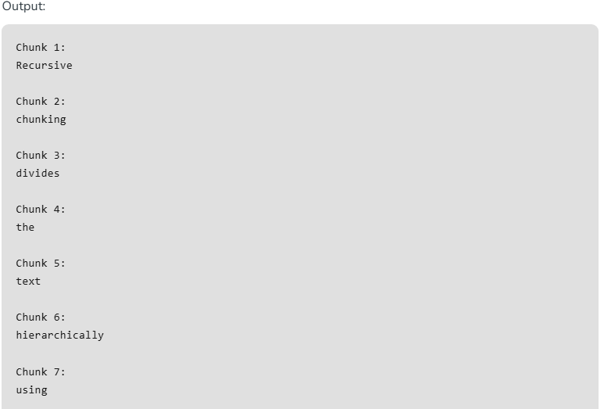
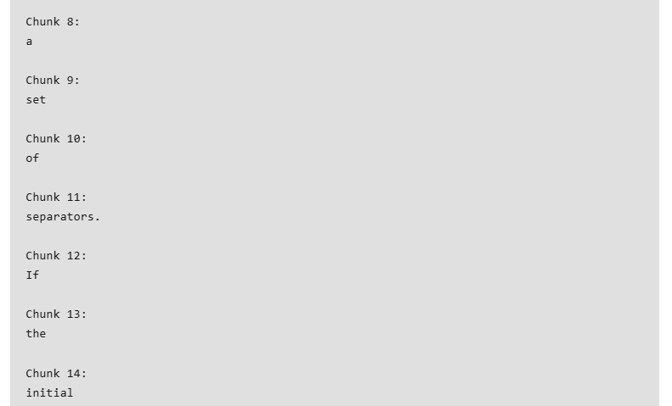
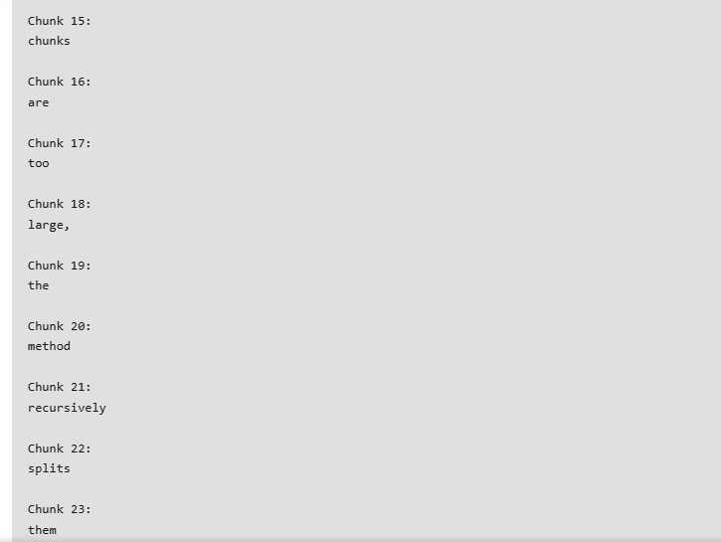

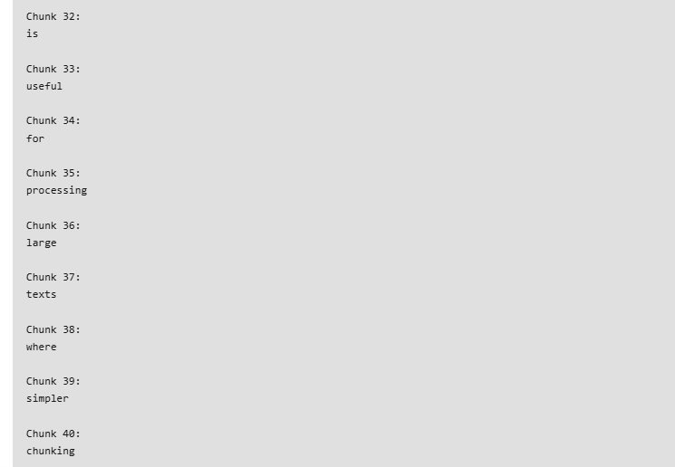
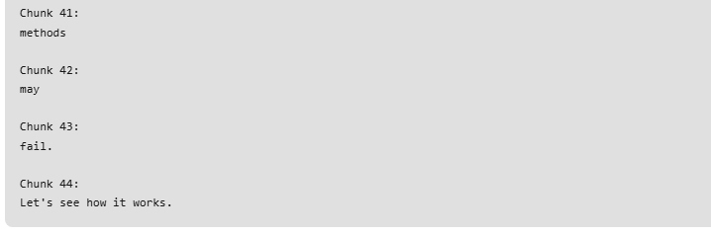

4. Semantic Chunking
Semantic chunking involves grouping sentences or phrases based on their semantic similarity. This method often uses clustering algorithms or embedding models.
- The embed_sentences function uses the Universal Sentence Encoder to convert sentences into numerical embeddings. This pre-trained model captures the semantic meaning of each sentence.
- The semantic_chunk function embeds the sentences and then applies the KMeans clustering algorithm to group similar sentences together.
- The number of clusters (num_clusters) is a parameter that determines how many groups the sentences will be divided into.
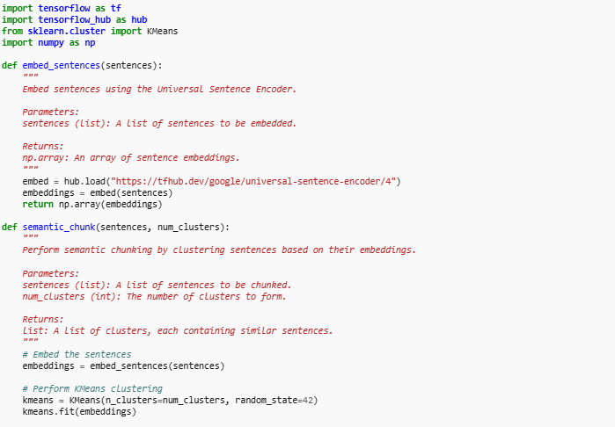
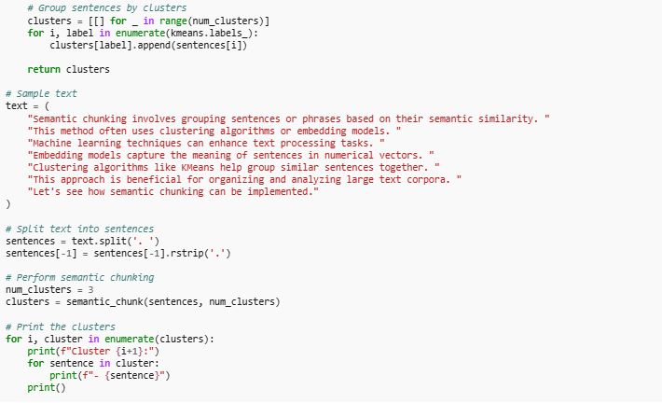
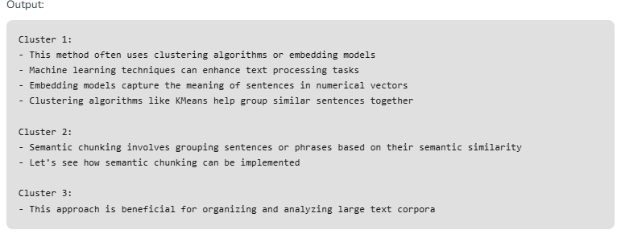

5. Content-Aware Chunking
Content-aware chunking adapts the chunking strategy based on the nature of the text. For instance, it can use different separators for different content types (e.g., paragraphs, lists).
- The content_aware_chunk function takes the input text and performs chunking based on the content type.
- Different regular expressions are used to define separators for paragraphs, bullet points, and numbered lists.
  - The text is first split into paragraphs using the regular expression r'\n\n+', which matches one or more newline characters.
  - If a paragraph contains bullet points (indicated by a newline followed by a hyphen), it is split further using the regular expression r'\n- '.
  - If a paragraph contains numbered list items (indicated by a newline followed by a digit and a period), it is split further using the regular expression r'\n\d+\. '.
  - Paragraphs without bullet points or numbered lists are treated as regular paragraphs and added to the chunks list directly.
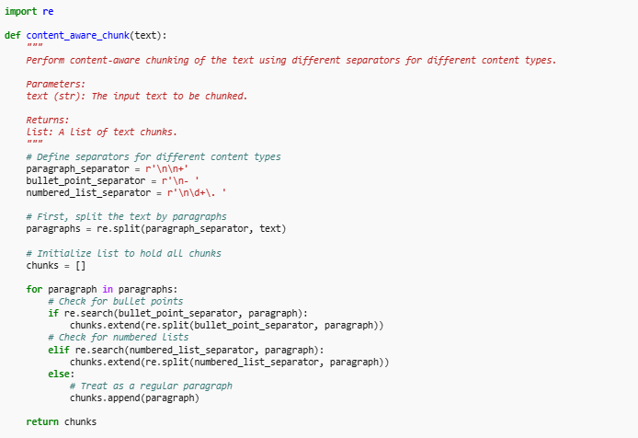
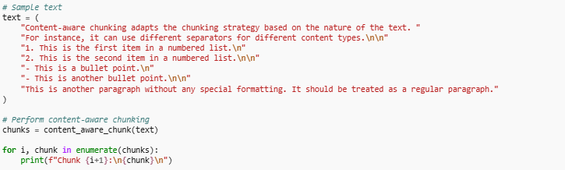
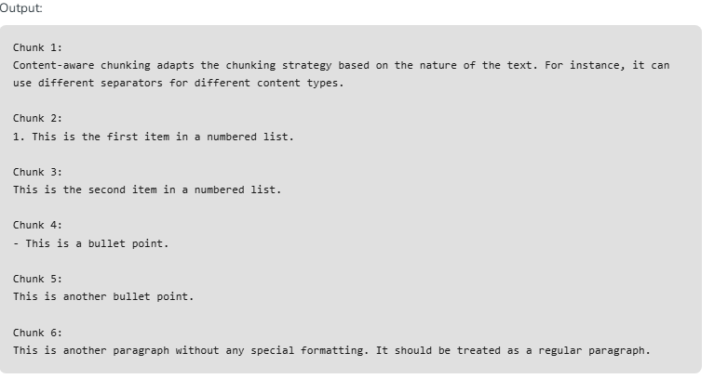

6. Propositional Chunking
Propositional chunking involves breaking down text into atomic units called propositions, each representing a distinct fact or idea. This method can be useful in tasks such as information extraction, summarization, and natural language understanding.
- The extract_propositions function uses SpaCy to parse the input text and identify propositions.
- It loads the SpaCy English model (en_core_web_sm) and processes the text.
- The text is parsed into sentences using SpaCy's sentence boundary detection.
- For each sentence, the function looks for tokens with the dependency labels ROOT (the main verb of the sentence) and conj (conjunct verbs).
- Each proposition is formed by extracting the subtree of the ROOT or conj token, which represents the phrase rooted at that token.

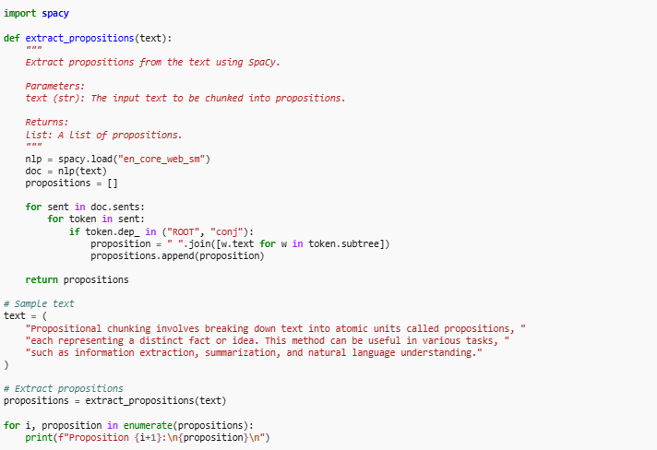
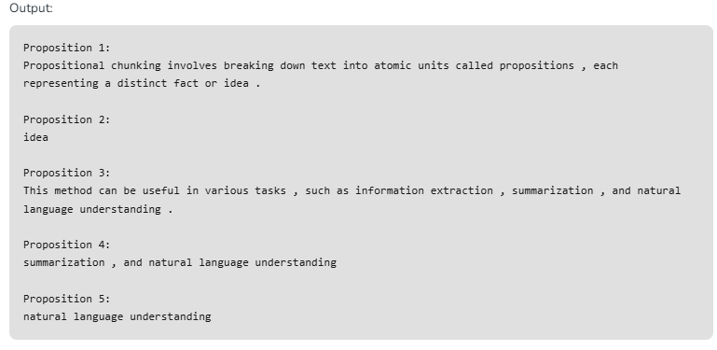

Use Cases for Text Chunking
Different chunking methods are suitable for various NLP applications:
- Text Summarization: Sentence splitting and semantic chunking are ideal as they preserve the context and meaning of the text.
- Sentiment Analysis: Fixed-size chunking can be effective for large datasets, while sentence splitting offers more precise sentiment detection.
- Information Extraction: Semantic chunking excels in extracting relevant entities and phrases.
- Text Classification: Recursive chunking provides balanced chunks for training classifiers.
- Machine Translation: Sentence splitting ensures coherent translations by maintaining sentence boundaries.

Choosing the Right Chunking Method
Selecting the appropriate chunking method depends on several factors:
- Text Structure: Consider the nature of the text (e.g., narrative, technical, conversational).
- Application Requirements: Determine the specific needs of your NLP task (e.g., precision, efficiency, context preservation).
- Computational Resources: Assess the available computational power and memory.

Conclusion
Text chunking is a critical step in NLP that significantly impacts the performance and accuracy of various applications. By understanding and comparing different chunking methods, you can choose the most suitable approach for your specific needs. Whether you opt for fixed-size chunking, sentence splitting, recursive chunking, or semantic chunking, each method offers unique advantages and challenges that must be carefully considered.

Information Extraction in NLP

Information Extraction (IE) in Natural Language Processing (NLP) is a crucial technology that aims to automatically extract structured information from unstructured text. This process involves identifying and pulling out specific pieces of data, such as names, dates, relationships, and more, to transform vast amounts of text into useful, organized information.
Information Extraction in NLP is a transformative technology that converts unstructured text into structured, actionable information. By leveraging techniques such as Named Entity Recognition, Relationship Extraction, and Event Extraction, IE enables efficient data processing and supports decision-making across various industries. Despite challenges such as language ambiguity and the need for domain-specific adaptation, advancements in machine learning and integration with other NLP technologies promise a bright future for IE.

Importance of Information Extraction
- Enhancing Data Usability: IE helps in converting unstructured text, which constitutes a significant portion of the data available, into structured formats that are easier to analyze and utilize.
- Automating Data Processing: By automating the extraction process, IE reduces the need for manual data entry and analysis, saving time and resources.
- Supporting Decision-Making: Extracted information can be used for decision-making in various domains such as healthcare, finance, and customer service, providing actionable insights from large datasets.

Key Components of Information Extraction

Named Entity Recognition (NER)
NER identifies and classifies entities within a text into predefined categories such as the names of persons, organizations, locations, dates, etc.

Relationship Extraction
This involves identifying and categorizing the relationships between entities within a text, helping to build a network of connections and insights.

Event Extraction
Event extraction identifies specific occurrences described in the text and their attributes, such as what happened, who was involved, and where and when it occurred.

Information Extraction Techniques in NLP
Here are the main techniques used in IE:

1. Named Entity Recognition (NER)
Definition: Identifying and classifying named entities (e.g., persons, organizations, locations, dates) in text.
Techniques:
- Rule-based approaches: Utilize predefined rules and patterns.
- Statistical models: Use probabilistic models like Hidden Markov Models (HMM) and Conditional Random Fields (CRF).
- Deep learning: Leverage neural networks such as BiLSTM-CRF and transformers like BERT.

2. Relation Extraction
Definition: Identifying and categorizing relationships between entities within a text.
Techniques:
- Pattern-based: Uses patterns and linguistic rules.
- Supervised learning: Employs labeled data to train classifiers.
- Distant supervision: Uses a large amount of noisy labeled data from knowledge bases.
- Neural networks: Utilizes CNNs, RNNs, and transformers for relation classification.

3. Event Extraction
Definition: Detecting events and their participants, attributes, and temporal information.
Techniques:
- Template-based: Matches text with pre-defined event templates.
- Machine learning: Uses classifiers and sequence labeling methods.
- Deep learning: Applies RNNs, CNNs, and attention mechanisms to capture event structures.

4. Coreference Resolution
Definition: Determining when different expressions in a text refer to the same entity.
Techniques:
- Rule-based: Employs heuristic rules.
- Machine learning: Trains classifiers using features like gender, number, and syntactic role.
- Neural networks: Uses deep learning models like BiLSTM and transformers for coreference chains.

5. Template Filling
Definition: Extracting specific pieces of information to populate predefined templates.
Techniques:
- Rule-based: Matches text to slots based on rules.
- Machine learning: Uses classifiers to fill template slots.
- Hybrid methods: Combine rules and machine learning for better accuracy.

6. Open Information Extraction (OpenIE)
Definition: Extracting tuples of arbitrary relations and arguments from text.
Techniques:
- Pattern-based: Utilizes linguistic patterns to identify relational triples.
- Statistical: Uses probabilistic models to determine the confidence of extracted relations.
- Neural OpenIE: Leverages deep learning models to improve the extraction process.

Performing Information Extraction using NER
This example demonstrates extracting named entities from text, which is a common IE task.

Load the SpaCy Model and Perform NER
- Loading the SpaCy Model: We load the en_core_web_sm model which is a small English model trained on various text corpora.
- Processing Text: The text is processed to create a Doc object which contains linguistic annotations.
- Extracting Named Entities: We iterate over the named entities in the Doc object and print the entity text, start character, end character, and entity label.
import spacy
# Load the pre-trained SpaCy model
nlp = spacy.load("en_core_web_sm")
# Sample text
text = "Apple is looking at buying U.K. startup for $1 billion. The deal is expected to close by January 2022."
# Process the text
doc = nlp(text)
# Extract and print named entities
for ent in doc.ents:
print(ent.text, ent.start_char, ent.end_char, ent.label_)
Output:
Apple 0 5 ORG
U.K. 27 31 GPE
$1 billion 44 54 MONEY
January 2022 89 101 DATE

Example with Relation Extraction using SpaCy and a Custom Pipeline Component
- Custom Component: The custom extract_relations component uses SpaCy's Matcher to identify patterns of interest (subject-verb-object relations in this case).
- Pattern Matching: We define a pattern that matches the dependency parse tree for subject-verb-object constructs.
- Registering Component: We register the custom component with SpaCy using the Doc.set_extension method.
import spacy
from spacy.tokens import Doc, Span
from spacy.matcher import Matcher
# Load the pre-trained SpaCy model
nlp = spacy.load("en_core_web_sm")
# Define the custom component
def extract_relations(doc):
matcher = Matcher(nlp.vocab)
# Define patterns for matching relations
pattern = [
{'DEP': 'nsubj'},
{'DEP': 'aux', 'OP': '?'},
{'DEP': 'ROOT'},
{'DEP': 'det', 'OP': '?'},
{'DEP': 'amod', 'OP': '*'},
{'DEP': 'dobj'}
]
matcher.add("relation_pattern", [pattern])
matches = matcher(doc)
relations = []
for match_id, start, end in matches:
span = doc[start:end]
relations.append((span.text, span.root.dep_))
return relations

# Register the custom component with SpaCy
Doc.set_extension("relations", getter=extract_relations, force=True)
# Sample text
text = "Apple is acquiring a U.K. startup."
# Process the text
doc = nlp(text)
# Extract and print relations
relations = doc._.relations
for relation in relations:
print(relation)
from spacy import displacy
# Visualize the dependency parse tree
displacy.render(doc, style="dep", jupyter=True)
Output:
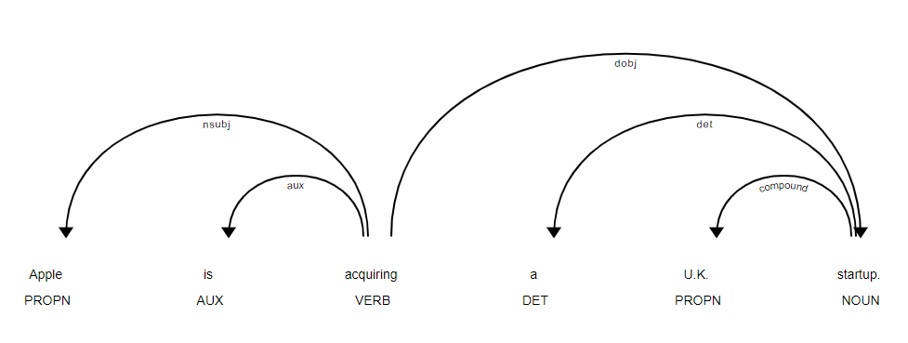

Applications of Information Extraction
- Healthcare: IE can extract patient information from clinical notes, aiding in medical research, diagnosis, and treatment planning.
- Finance: In finance, IE helps in extracting key information from financial reports, news articles, and market analysis, supporting investment decisions and risk management.
- Customer Service: By extracting information from customer feedback, companies can identify common issues, improve service, and enhance customer satisfaction.

Challenges in Information Extraction
- Ambiguity and Variability of Language: Human language is inherently ambiguous and varies greatly in structure and style, making accurate extraction challenging.
- Domain-Specific Adaptation: IE systems need to be tailored to specific domains to achieve high accuracy, requiring substantial effort in training and customization.
- Data Quality and Annotation: The quality of the extracted information heavily depends on the quality of the training data and the annotations used to train IE models.

Future Trends in Information Extraction
- Advanced Machine Learning Models: The use of advanced models, such as transformers and deep learning techniques, is expected to enhance the accuracy and capability of IE systems.
- Integration with Other NLP Technologies: Combining IE with other NLP technologies like sentiment analysis, text summarization, and question answering can provide more comprehensive solutions.
- Real-Time Information Extraction: Developing systems capable of real-time information extraction can offer immediate insights and support dynamic decision-making processes.
II. Text Summarization:
Automatic Text Summarization is a key technique in Natural Language Processing (NLP) that uses algorithms to reduce large texts while preserving essential information. Although it doesn’t receive as much attention as other machine learning breakthroughs, text summarization technology has seen continuous improvements. By extracting key concepts and maintaining the original meaning, these systems can revolutionize industries such as banking, law, and healthcare, enabling faster decision-making and information retrieval.
There are two primary types of text summarization techniques:
- Extractive Summarization
- Abstractive Summarization

Extractive Summarization
Extractive summarization algorithms automatically generate summaries by selecting and combining key passages from the original text. Unlike human summarizers, these models focus on extracting the most important sentences without creating new content. The goal is to preserve the meaning of the original text while condensing it.
The TextRank algorithm is widely used for extractive summarization tasks. By ranking sentences based on their relevance and importance, it can generate a concise summary. Let's explore how this algorithm works with a sample text.

Utilizing TextRank Algorithm for Extractive Text Summarization
TextRank is implemented in the spaCy library. With the help of PyTextRank, a spaCy extension, we can efficiently apply the TextRank algorithm to summarize text. While extractive summarization provides a modified version of the original text by retaining key phrases, it does not generate entirely new content.

Prerequisites:
- spaCy: A Python library for NLP tasks.
- PyTextRank: A spaCy extension that implements the TextRank algorithm.
To install spaCy and the required language model, run the following commands:
!pip install spacy
!python3 -m spacy download en_core_web_lg
To install PyTextRank, run:
!pip install pytextrank
A simple implementation of spaCy and PyTextRank for automatic text summarization. The code installs the required packages, downloads the spaCy language model, and processes a lengthy text to extract key phrases and sentences. The summary is limited to two key phrases and two sentences.import spacy
import pytextrank

nlp = spacy.load("en_core_web_lg")
nlp.add_pipe("textrank")

example_text = """Deep learning (also known as deep structured learning) is part of a broader family of machine learning methods based on artificial neural networks with representation learning. Learning can be supervised, semi-supervised or unsupervised. Deep-learning architectures such as deep neural networks, deep belief networks, deep reinforcement learning, recurrent neural networks and convolutional neural networks have been applied to fields including computer vision, speech recognition, natural language processing,machine translation, bioinformatics, drug design, medical image analysis, material inspection and board game programs, where they have produced results comparable to and in some cases surpassing human expert performance. Artificial neural networks (ANNs) were inspired by information processing and distributed communication nodes in biological systems. ANNs have various differences from biological brains. Specifically,neural networks tend to be static and symbolic, while the biological brain of most living organisms is dynamic (plastic) and analogue. The adjective "deep" in deep learning refers to the use of multiple layers in the network. Early work showed that a linear perceptron cannot be a universal classifier, but that a network with a nonpolynomial activation function with one hidden layer of unbounded width can. Deep learning is a modern variation which is concerned with an unbounded number of layers of bounded size, which permits practical application and optimized implementation, while retaining theoretical universality under mild conditions. In deep learning the layers are also permitted to be heterogeneous and to deviate widely from biologically informed connectionist models, for the sake of efficiency, trainability and understandability, whence the structured part."""
print('Original Document Size:',len(example_text))
doc = nlp(example_text)
for sent in doc._.textrank.summary(limit_phrases=2, limit_sentences=2):
print(sent)
print('Summary Length:',len(sent))
Output:
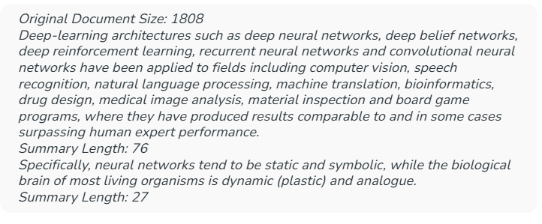

Abstractive Summarization
Abstractive summarization generates entirely new sentences to convey key ideas from the original text. Unlike extractive summarization, which selects and rearranges sentences from the original content, abstractive methods rephrase information in a more concise and coherent manner, often using new vocabulary that wasn't present in the original.
Abstractive summarization has gained prominence with the advent of Transformer models, which have revolutionized NLP tasks. Initially, models based on recurrent neural networks (RNNs) were used for text summarization, but Transformers introduced a unique architecture that significantly improved performance.

PEGASUS: A Transformer Model for Text Summarization
PEGASUS is a Transformer-based model designed specifically for text summarization. Unlike other models, PEGASUS uses a unique pre-training strategy where critical sentences are masked during training. The model is then tasked with generating these hidden sentences, which enables it to create more accurate and coherent summaries.
To use the PEGASUS model for text summarization, you need to install the following libraries and frameworks:
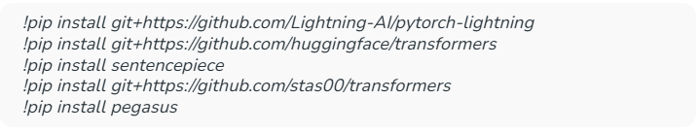
Once the dependencies are installed, you can begin summarizing text with the PEGASUS model. Below is an example code snippet that uses the Hugging Face Transformers library to load the model, tokenize the input text, generate a summary, and display it.
from transformers import pipeline
from transformers import PegasusForConditionalGeneration, PegasusTokenizer
# Pick model
model_name = "google/pegasus-xsum"
# Load pretrained tokenizer
pegasus_tokenizer = PegasusTokenizer.from_pretrained(model_name)
example_text = """Deep learning (also known as deep structured learning) is part of a broader family of machine learning methods based on artificial neural networks with representation learning. Learning can be supervised, semi-supervised or unsupervised. Deep-learning architectures such as deep neural networks, deep belief networks, deep reinforcement learning, recurrent neural networks and convolutional neural networks have been applied to fields including computer vision, speech recognition, natural language processing, machine translation, bioinformatics, drug design, medical image analysis, material inspection and board game programs, where they have produced results
comparable to and in some cases surpassing human expert performance. Artificial neural networks (ANNs) were inspired by information processing and distributed communication nodes in biological systems. ANNs have various differences from biological brains. Specifically, neural networks tend to be static and symbolic, while the biological brain of most living organisms is dynamic (plastic) and analogue. The adjective "deep" in deep learning refers to the use of multiple layers in the network. Early work showed that a linear perceptron cannot be a universal classifier, but that a network with a nonpolynomial activation function with one hidden layer of unbounded width can. Deep learning is a modern variation which is concerned with an unbounded number of layers of bounded size, which permits practical application and optimized implementation, while retaining theoretical universality under mild conditions. In deep learning the layers are also permitted to be heterogeneous and to deviate widely from biologically informed connectionist models, for the sake of efficiency, trainability and understandability, whence the structured part."""

print('Original Document Size:',len(example_text))
# Define PEGASUS model
pegasus_model = PegasusForConditionalGeneration.from_pretrained(model_name)
# Create tokens
tokens = pegasus_tokenizer(example_text, truncation=True, padding="longest", return_tensors="pt")
# Generate the summary
encoded_summary = pegasus_model.generate(**tokens)
# Decode the summarized text
decoded_summary = pegasus_tokenizer.decode(encoded_summary[0], skip_special_tokens=True)
# Print the summary
print('Decoded Summary :',decoded_summary)
summarizer = pipeline(
"summarization",
model=model_name,
tokenizer=pegasus_tokenizer,
framework="pt"
)
summary = summarizer(example_text, min_length=30, max_length=150)
summary[0]["summary_text"]
Output:
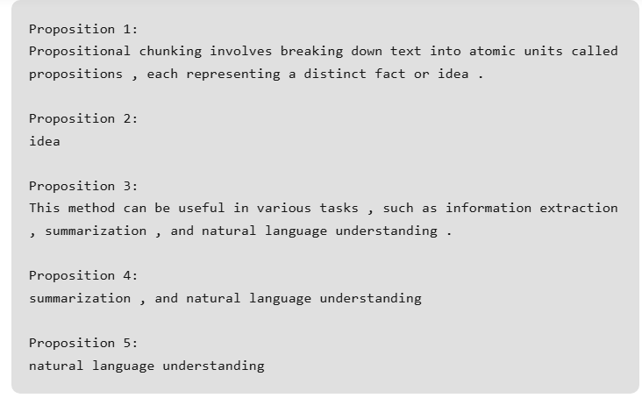
The future of text summarization looks promising, with advancements in both extractive and abstractive methods, powered by models like PEGASUS. As these techniques evolve, they will enable more accurate and intuitive summarization, transforming how we process vast amounts of information. This progress highlights the growing potential of AI in enhancing human comprehension and knowledge management.

What You're Aiming For
Read the following document:

"The Eiffel Tower, located in Paris, France, was constructed between 1887 and 1889 as the entrance arch to the 1889 World’s Fair.
It was designed by Gustave Eiffel’s engineering company and initially faced criticism from artists and intellectuals who considered it an eyesore.
Today, the Eiffel Tower is one of the most visited monuments in the world, attracting over 7 million visitors annually.
In 2015, special lighting systems were added to enhance its nighttime appearance and improve energy efficiency."

Instructions
Tasks:
- Apply a splitting strategy (Fixed-size, Semantic, or Metadata-based).
- Extract the key facts (dates, places, people, numbers, events…).
- Write a short summary of the document.

